PHD FAMILY WELFARE FOUNDATION
(Bulletin Points)

MAJOR PROGRAMME

PHDFWF organized its flagship programme ‘HUNAR UNLIMITED 2024’
PHD Family Welfare Foundation organized its flagship programme 'Hunar Unlimited 2024' on January 18, 2024 at the PHD House, New Delhi. Shri Rajesh Aggarwal, Secretary, Department of Empowerment of Persons with Disabilities (Divyangjan), Ministry of Social Justice and Empowerment, GOI was the Chief Guest of the programme. The inaugural lamp was lit by the Chief Guest Shri Rajesh Aggarwal in the gracious presence of Dr. Rashmi Singh, IAS, Principal Resident Commissioner & Secretary, Dept. of Administration, Jammu & Kashmir, Shri Sanjeev Agrawal, President, PHDCCI, Shri Shamsher Kanwar, Head, Jaquar Foundation, Dr. Mathew Varghese, Head, Orthopaedic Department, St. Stephens Hospital and Ms. Anuradha Goel, Chairperson, PHDFWF. Ms. Anuradha Goel in her address welcomed the guests and the participants and briefed about the welfare work done by the PHDFWF. An art competition for the special abled artist was also organised to recognise their mural paintings and were given prizes on the basis of the judgement made by the renowned Artist Ms Nupur Kundu. The student beneficiaries from different skill development training centers of PHDFWF performed dances, skits, songs, and poems to showcase their talents. Shri Sanjeev Agrawal, President, PHDCCI thanked the Chief Guest for giving his valuable time for the programme and expressed his gratitude to all the supporters of the PHDFWF, Chairperson & GB members of PHDFWF and students performers. More than 350 audience enjoyed the programme. The theme of the programme was 'India's successful mission to the Moon'.
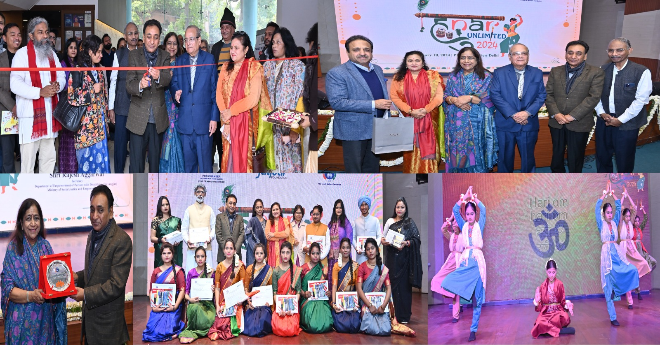

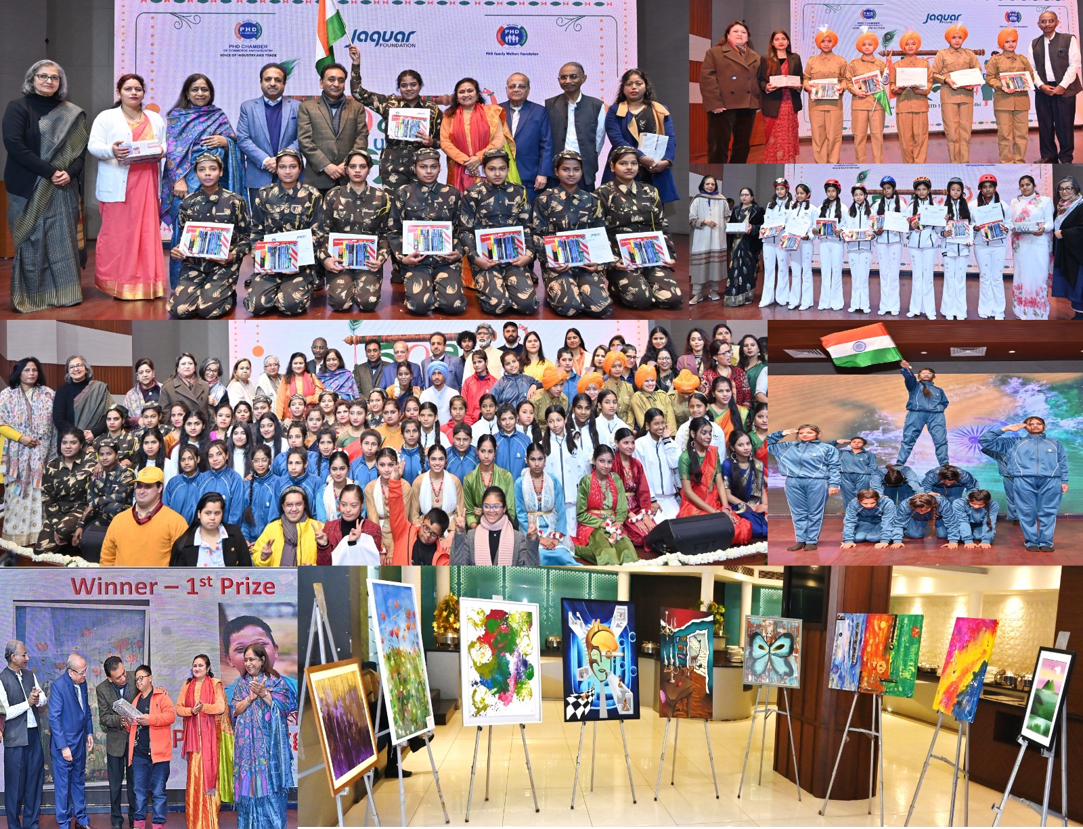

PHDFWF organized unique talk on Exploring Millets ‘A Journey of Nutrition and Culinary Artistry’
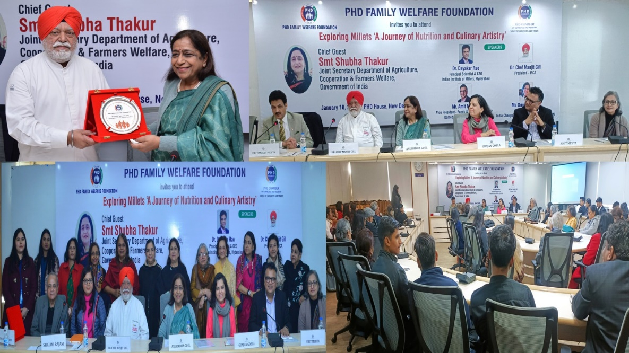

PHD Family Welfare Foundation organized a unique talk - Exploring Millets ‘A Journey of Nutrition and Culinary Artistry’ on January 10, 2024 at the PHD House, New Delhi. Ms. Anuradha Goel, Chairperson, PHDFWF briefed about the welfare work of the foundation being done from last 37 years and felicitated the distinguish speakers with mementoes. The moderator of the programme was Chef Gunjan Goela, India Chairperson for Culinary Arts, New Delhi. The programme featured three nationally and internationally acclaimed distinguished keynote speakers: Dr. Chef Manjit Gill, President of IFCA and Managing Director of Eco Green Hospitality; and Mr. Amit Mehta, Vice President - Foods, & Managing Director Kameda LT Foods India Pvt Ltd.; and millet coach Ms. Shalini Rajani.

Speakers shared their invaluable insights and passion for millets that has left an indelible mark on our minds. Their profound knowledge on the nutritional aspects of millets did enlighten us about their immense health benefits. The depth and clarity with which they all have presented the information have certainly inspired the audience to incorporate millets in daily diets. Their contributions have made 'Exploring Millets' an unforgettable journey, and requested everyone to embrace millets for their nutritional benefits and culinary versatility. The programme was followed by question and answers session. The vote of thanks was given by Dr. Ranjeet Mehta, Executive Director, PHDCCI.

The FWF skill development beneficiaries had also put-up stall displaying products made out of old cushion covers which included, handbags, lunch bag, slippers, oven mittens, floor mats, etc. The programme witnessed more than 100 audience.

EDUCATION
PHD Family Welfare Foundation is actively involved in advancing education by providing complimentary remedial classes at six locations and computer training courses at 20 centers in Delhi-NCR, Gujarat, and Rajasthan. This endeavor is designed to improve educational prospects and computer literacy in these areas, underscoring the foundation's dedication to empowering communities through easily accessible learning initiatives.
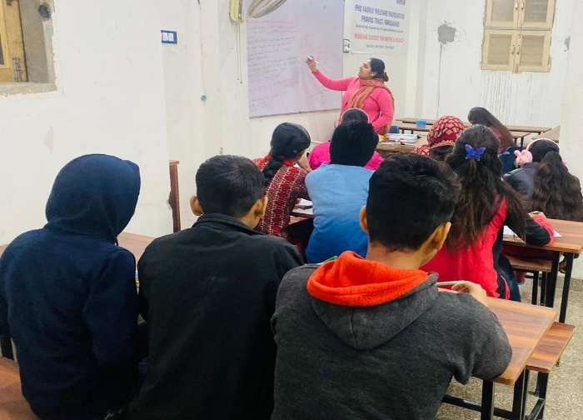
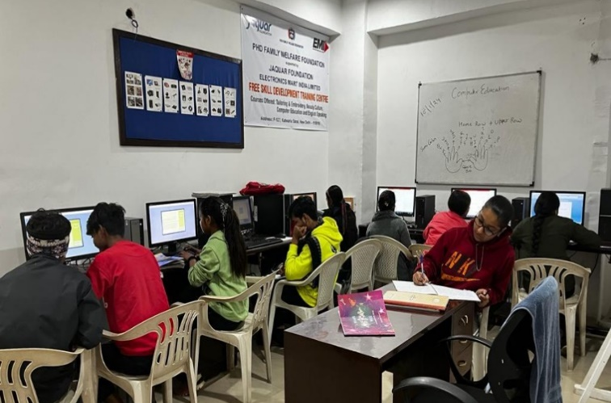

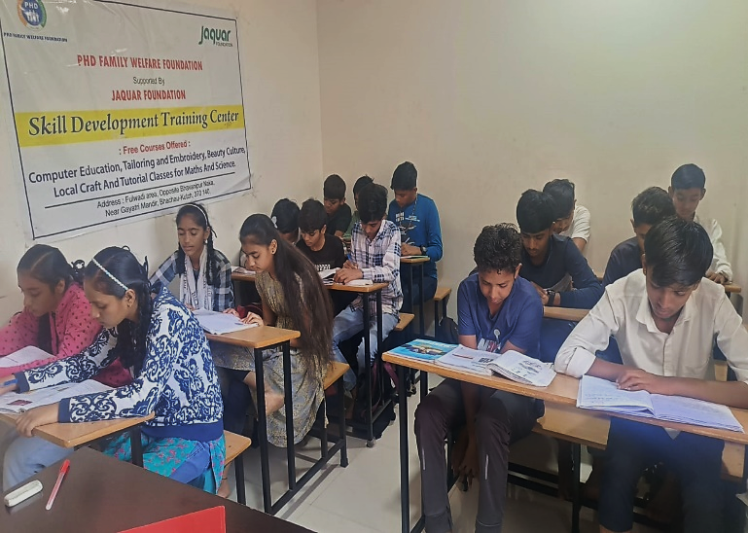
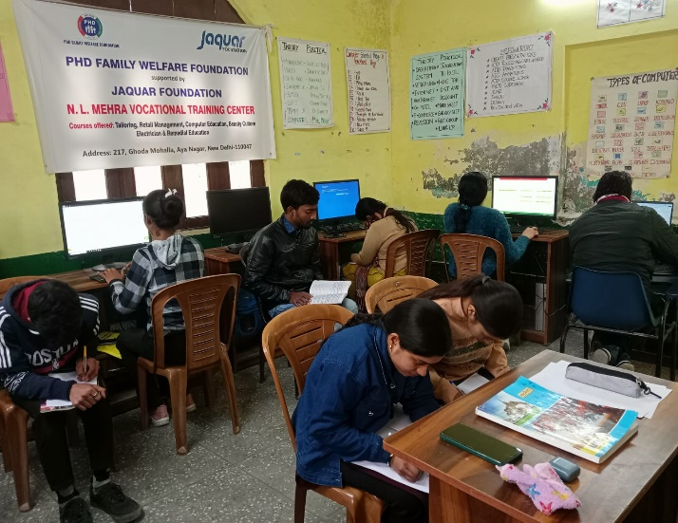

HEALTH CARE

PHD Family Welfare Foundation operates ten well-equipped mobile medical vans to deliver preventive, clinical, and diagnostic medical care directly to impoverished villages and resettlement colonies in Delhi-NCR, Rajasthan, Haryana, Uttar Pradesh, and Gujarat. These Mobile Medical Vans offer immediate diagnostic services, including blood sugar, hemoglobin, blood grouping, and blood pressure checks, along with free outpatient services for the underprivileged. The primary aim is to raise awareness and encourage appropriate behavior in seeking treatment for ailments, particularly among women and children.

The eye and dental mobile medical vans reach remote areas where residents have limited access to such free facilities, providing services such as eye checkups, scaling, temporary refilling, and free outpatient services. Both general and specialized mobile medical vans distribute medications and spectacles to patients on a daily basis. As of January 2024, PHDFWF's mobile medical vans have benefited approximately sixteen lakhs twenty-one thousand two hundred and five individuals. This outreach is made possible with the support of funding agencies like Jaquar Foundation, Imperial Auto Industries Ltd, Seth Madanlall Palriwala Foundation, Rotary Club of Delhi Premier, Sanganeria Foundation for Health and Education Trust, and AAOT.
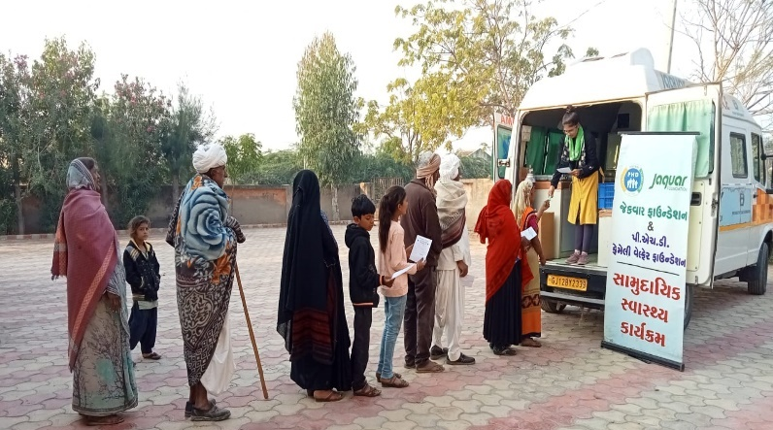
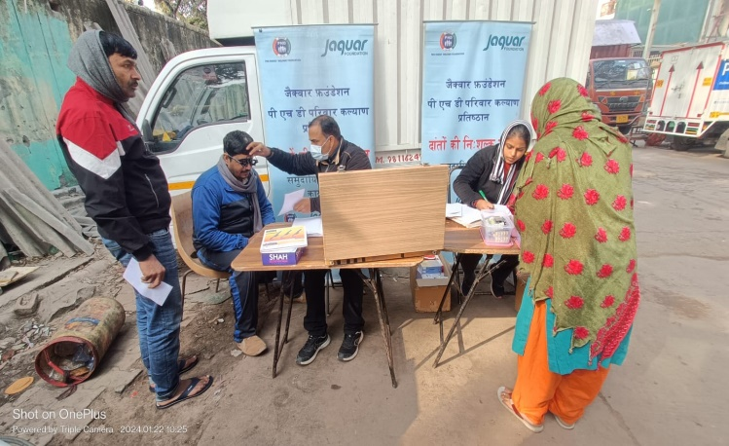
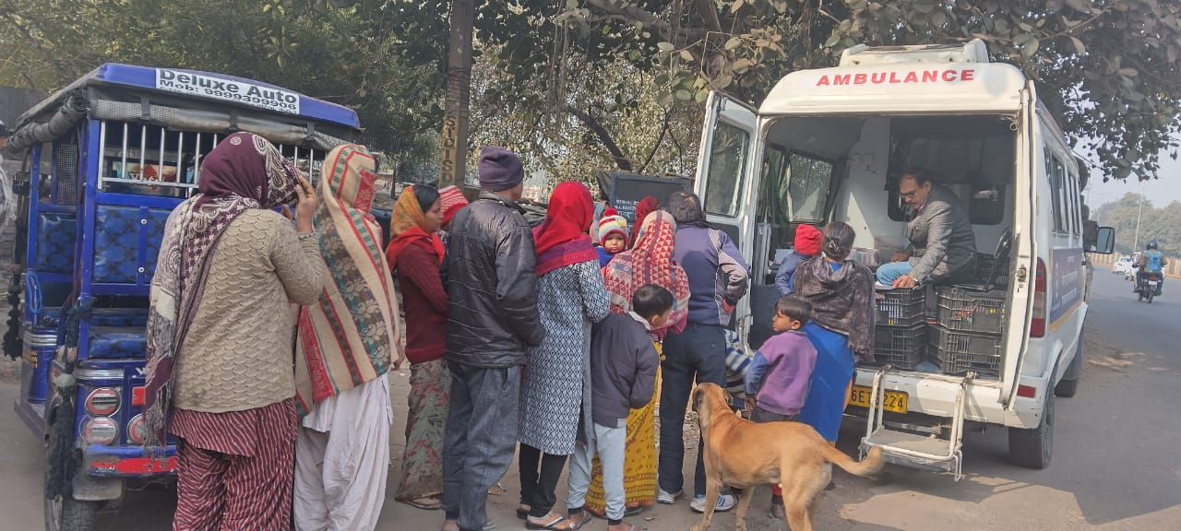
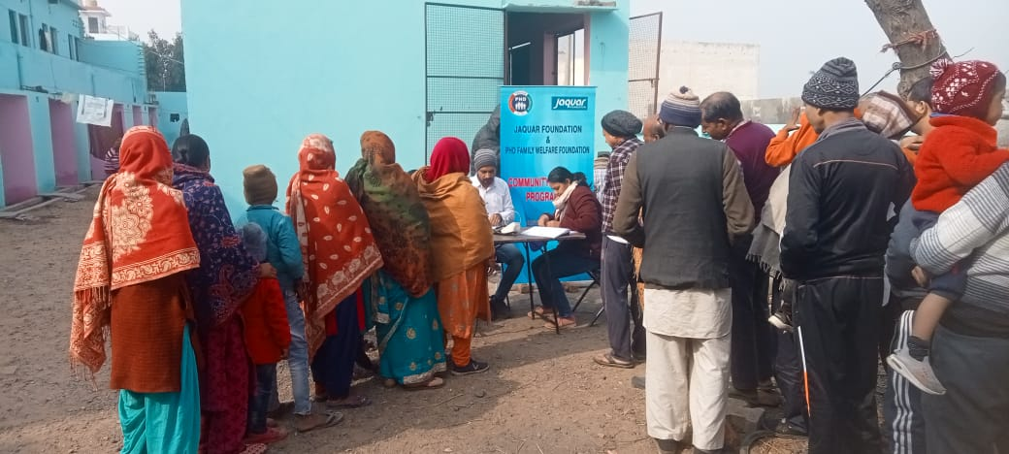

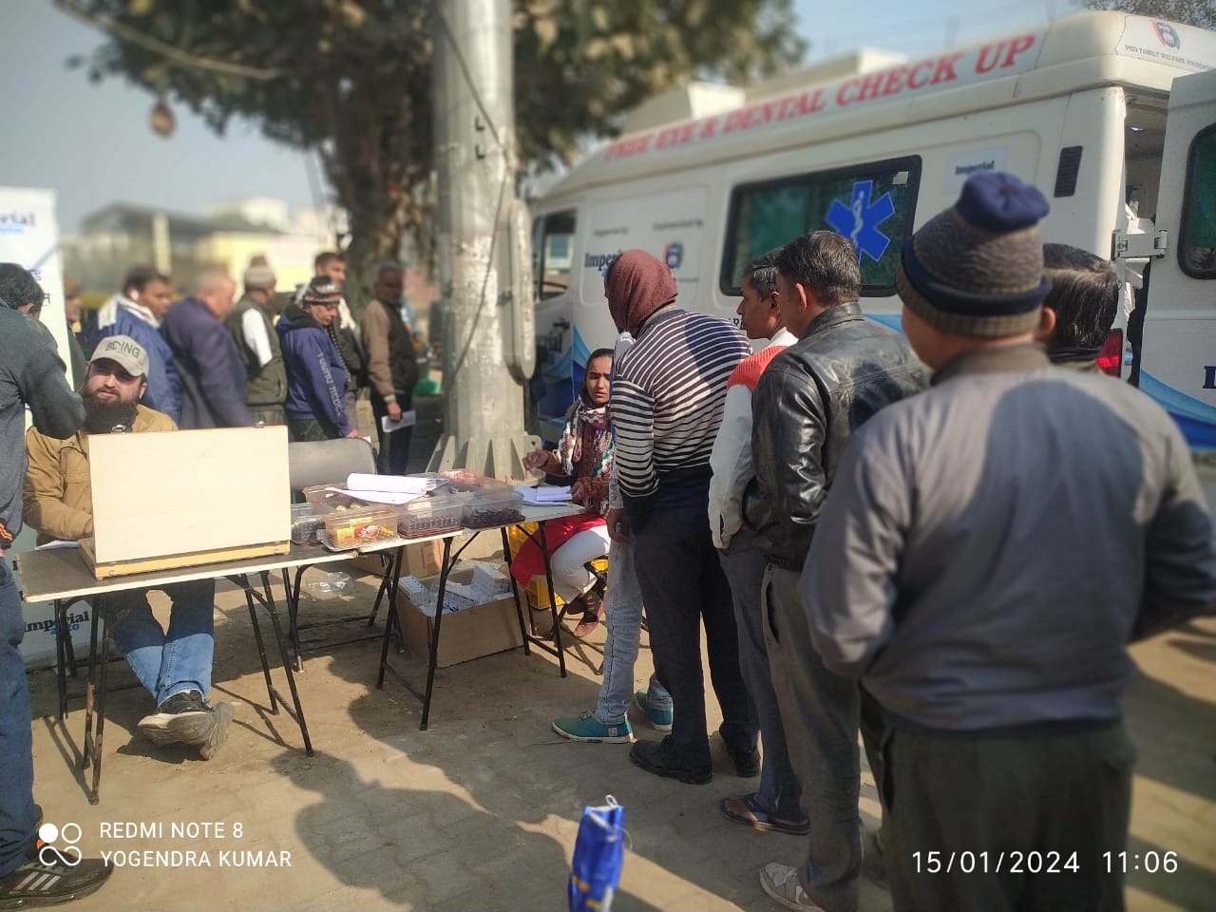

SKILL DEVELOPMENT & VOCATIONAL TRAINING
PHD Family Welfare Foundation (PHDFWF) is making a significant difference in communities by establishing 24 skill development centers nationwide. These centers play a crucial role in offering essential skills for free to empower their beneficiaries. The organization's impact spans across various states, including Odisha, Assam, Gujarat, Rajasthan, Haryana, and Delhi-NCR. PHDFWF is dedicated to addressing the unique needs of each community through vocational training and skill development initiatives, supported by funding agencies such as SMPF, Jaquar Foundation, Hindustan Tin Works, Kajaria Ceramics, L&T Prayas Trust, MG Goyal Gases, and others.
Through these endeavors, PHDFWF not only provides training but also creates opportunities for underprivileged women and youth to improve their lives, enabling them to become self-reliant and contribute meaningfully to society while supporting their families. As of January 2024, approximately fifty-three thousand individuals have already benefited from PHDFWF's initiatives. The collaboration with various organizations reflects a shared commitment to social welfare and community development. PHDFWF's skill development centers serve as symbols of hope, promoting growth and empowerment in communities nationwide.
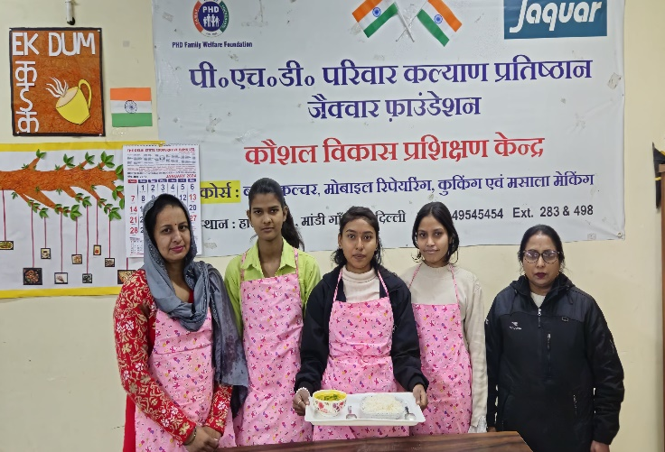
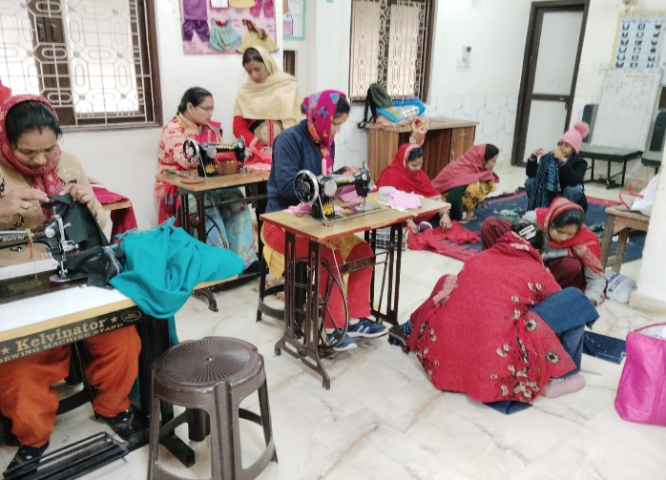
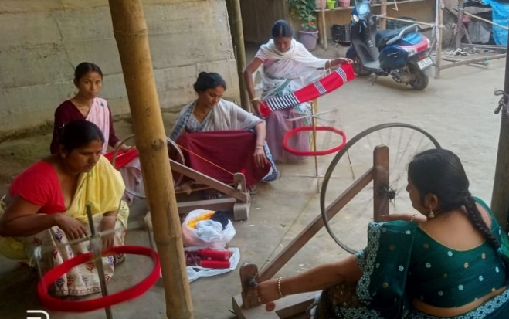
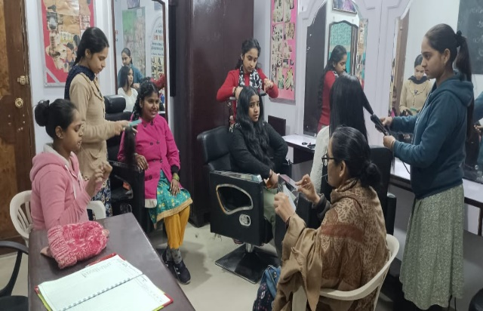
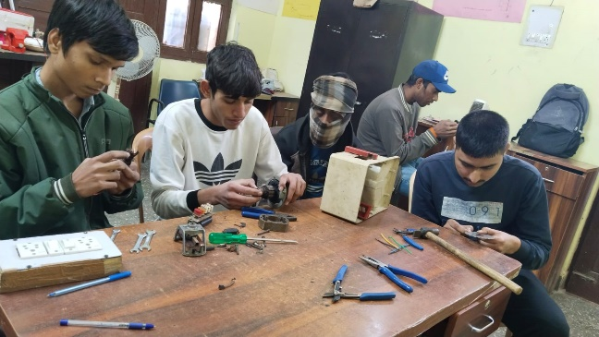
Cooking
Tailoring & Embroidery
Hand-Weaving
Beauty Culture

